WELCOME TO CS-521!!!

Tue - Thu, 6-7:30 p.m.

Lecture 8 (Nov 29, 2020)

Week 4:

Homework 4

Quiz 4

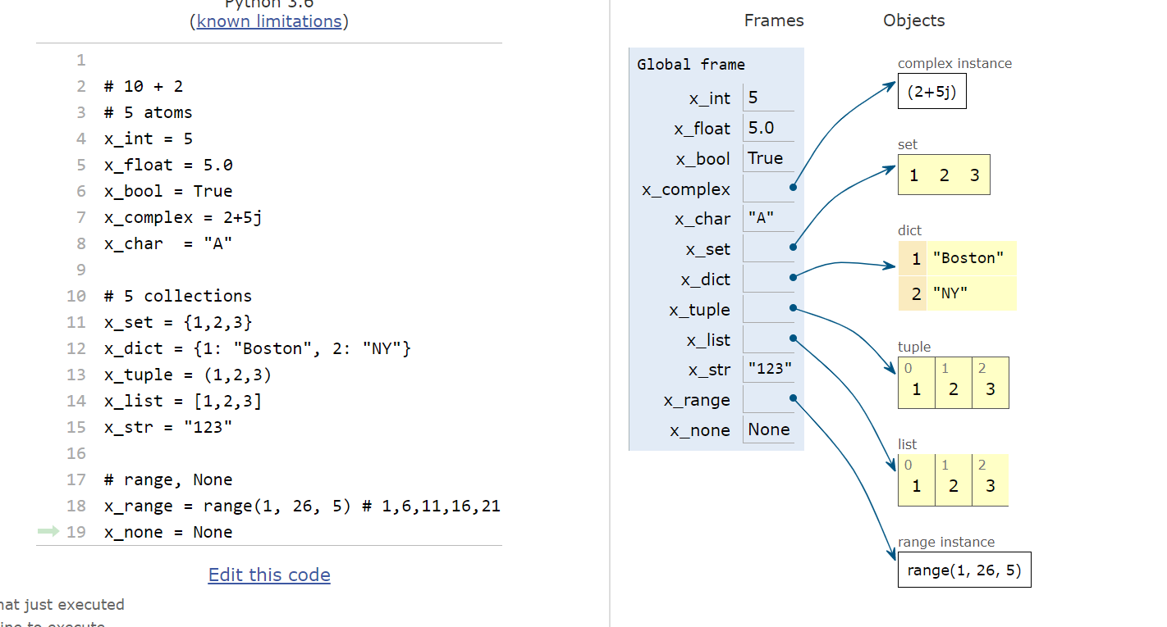

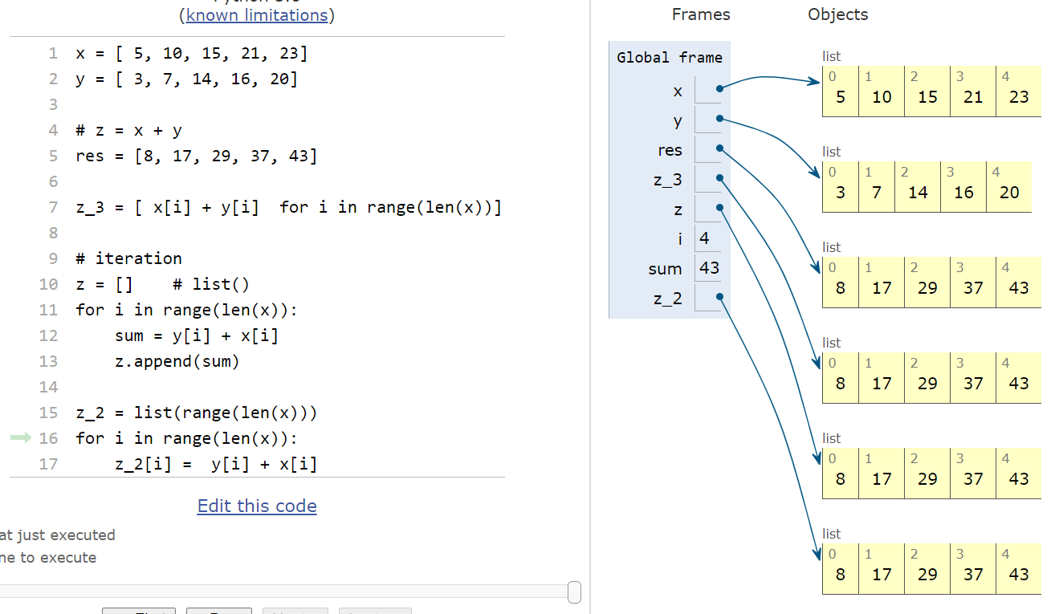

TUPLES:

(“restricted lists”)

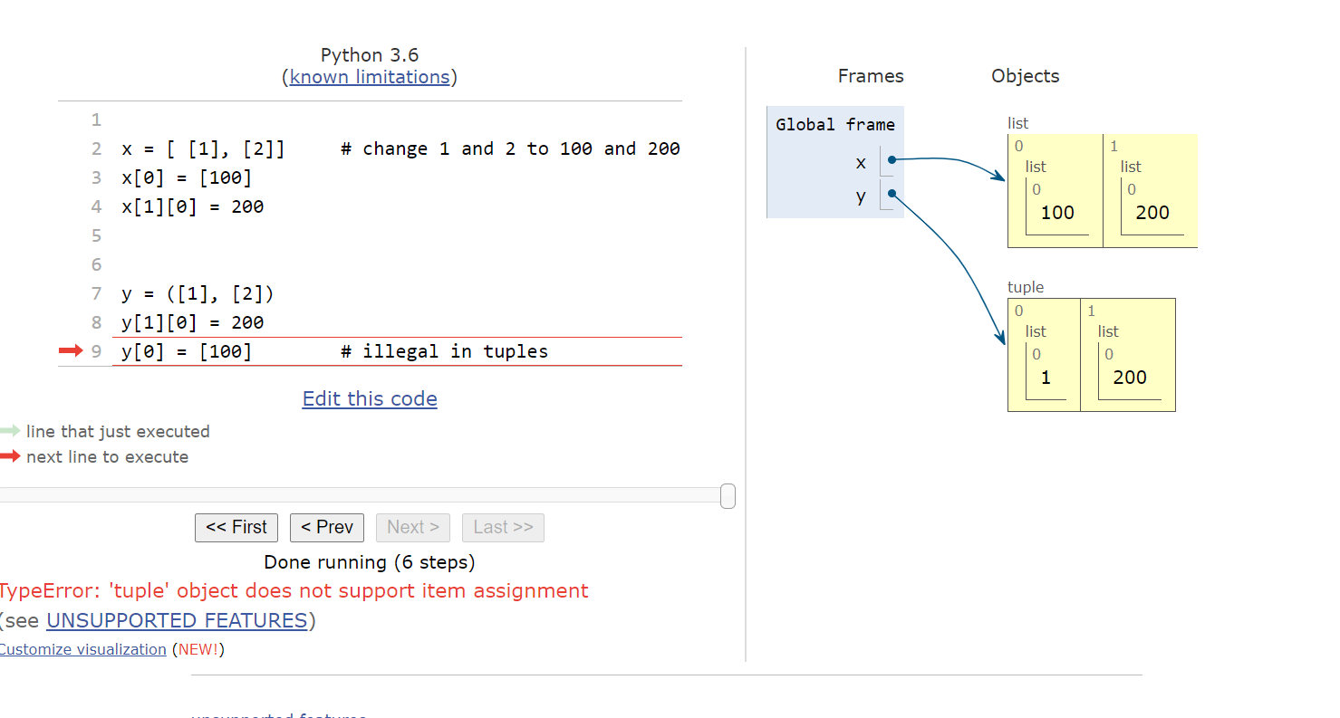

immutable objects (cannot replace an element at a particular position)

but if a tuple contains a mutable element, you can “mutate” this element in-place

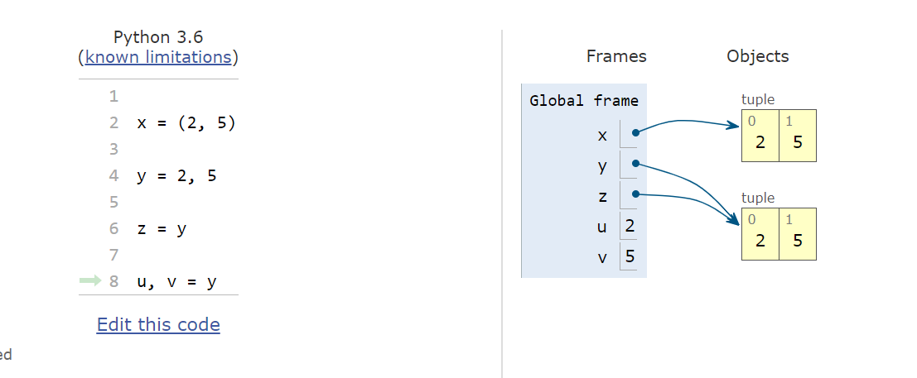

example: swap 2 elements using a tuple

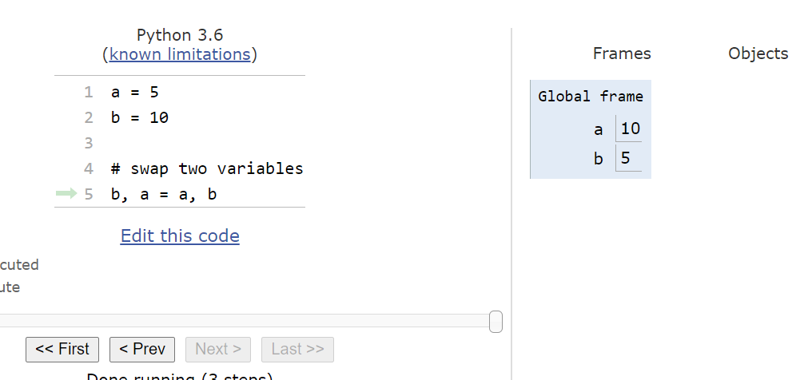

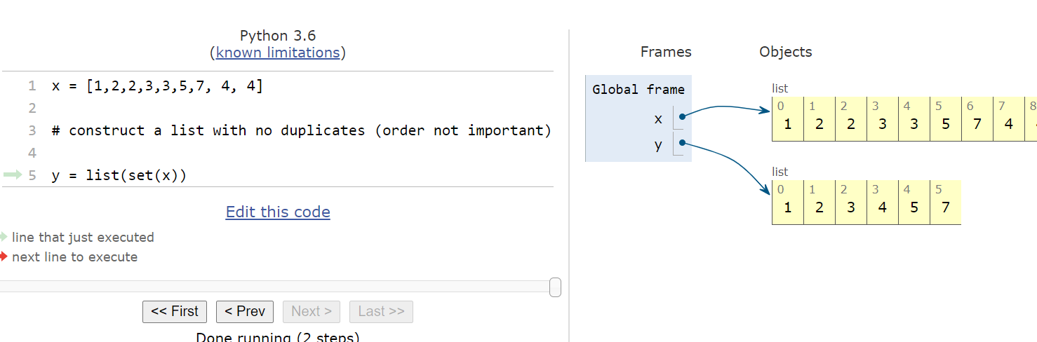

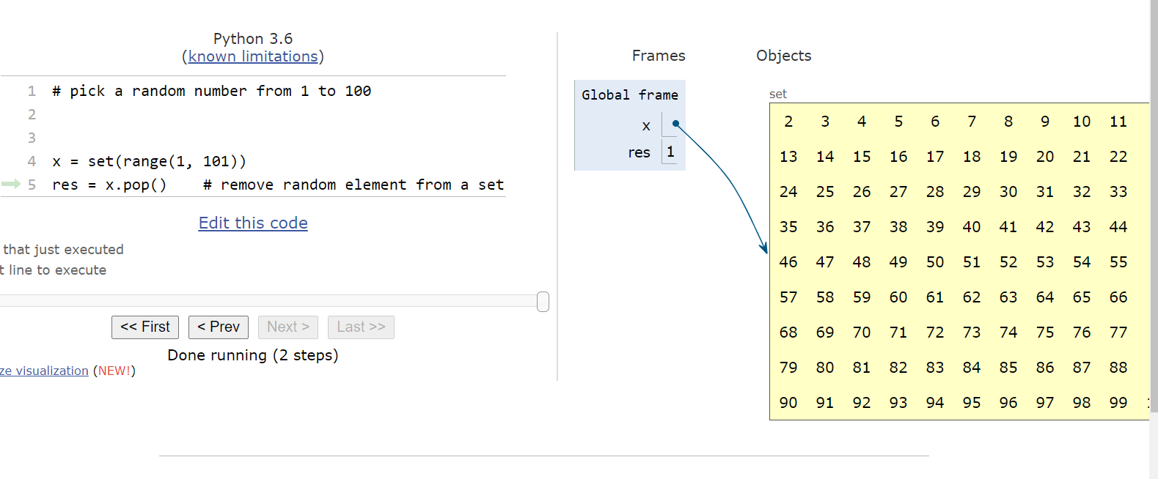

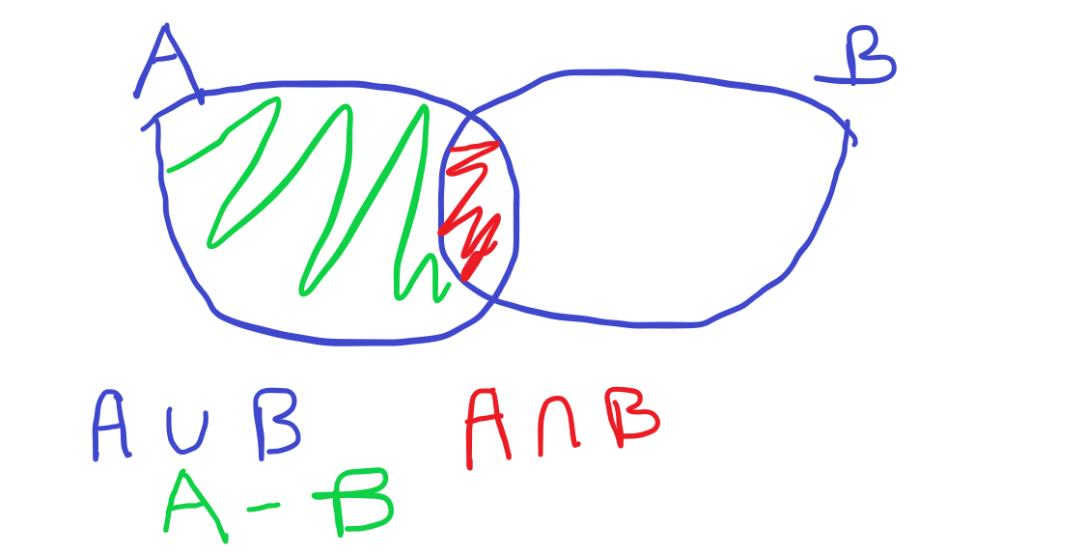

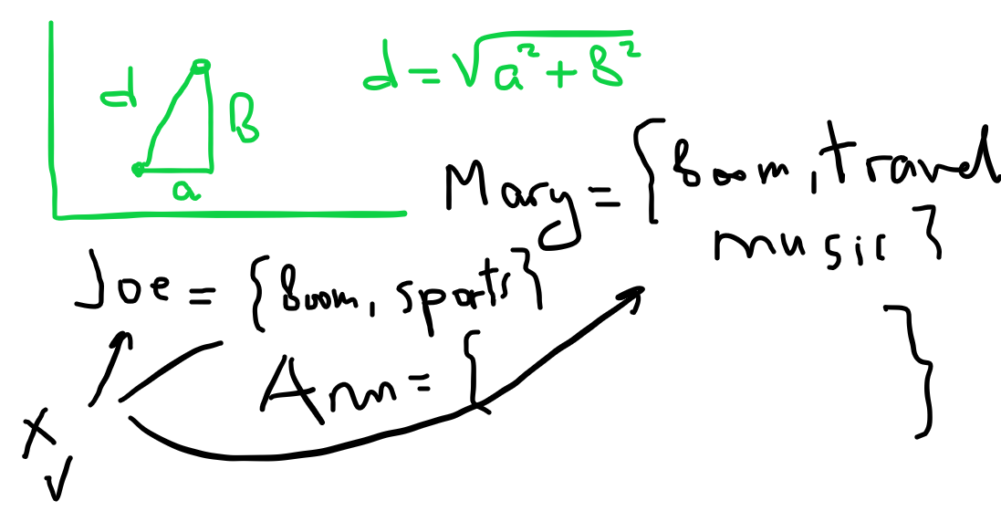

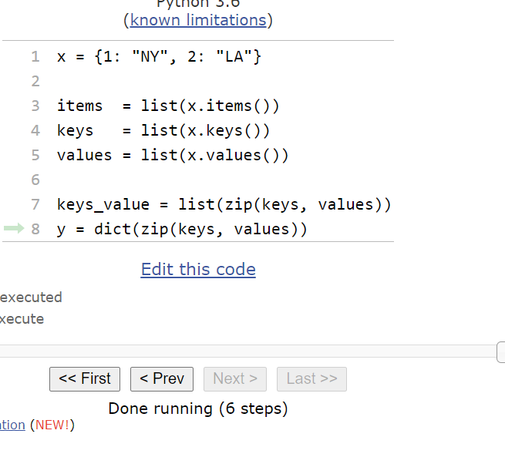

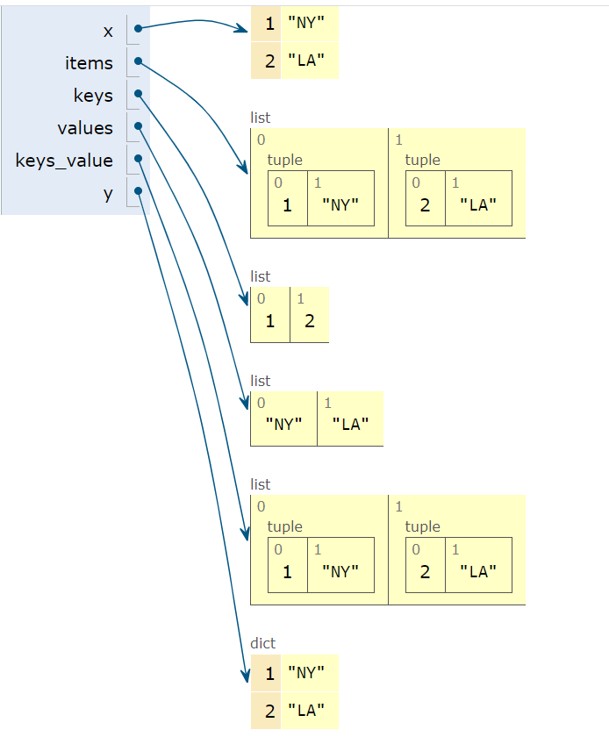

note on zip (in case of length mismatch)

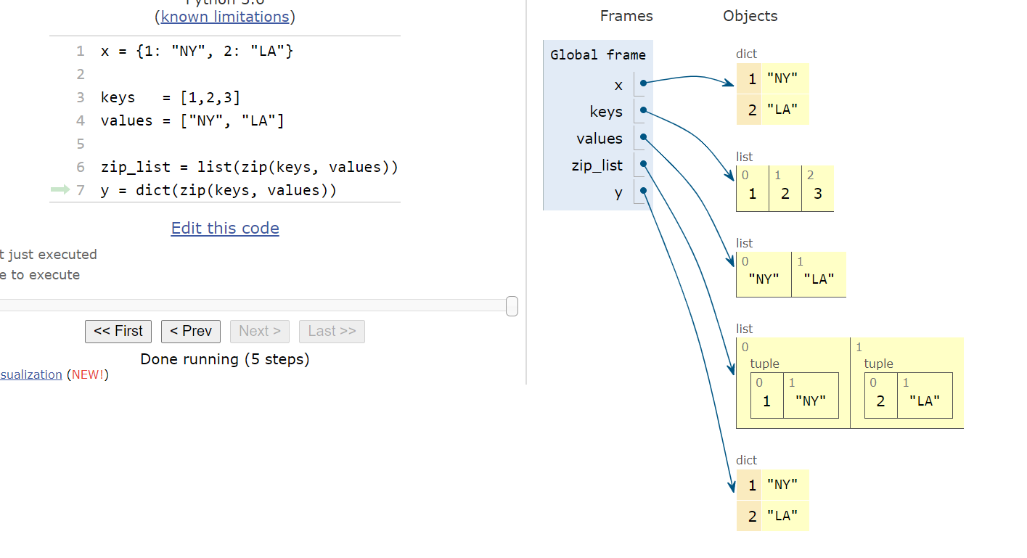

note on zip function:

1. can use many lists (>=2)
2. can use both lists and tuples

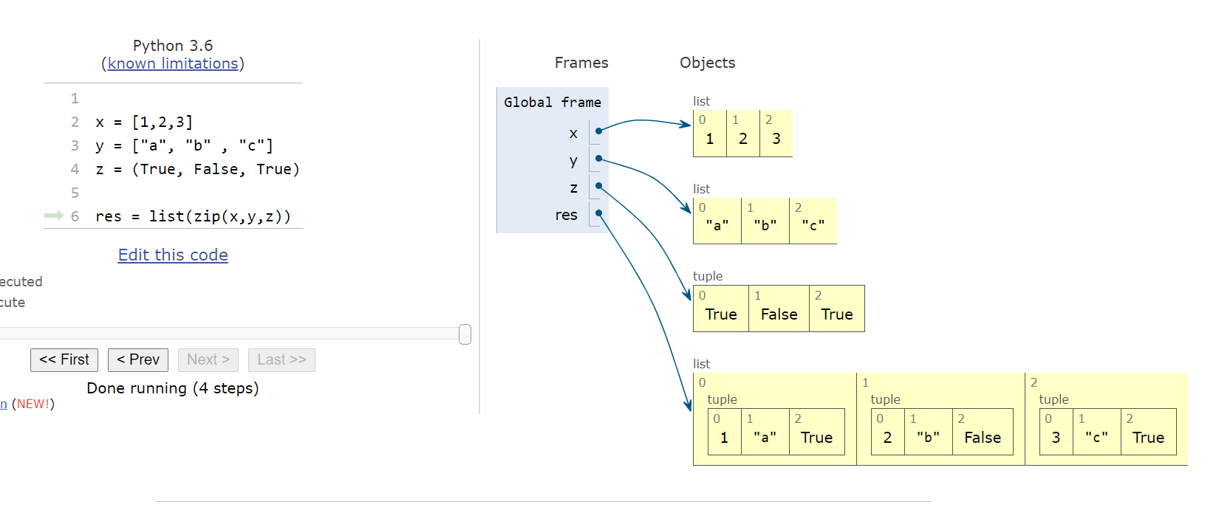

NEXT WEEK: focus on functions

in two weeks: focus on classes and object –oriented programming

reminder: if collections contain mutable components, then copy does “shallow copy only”

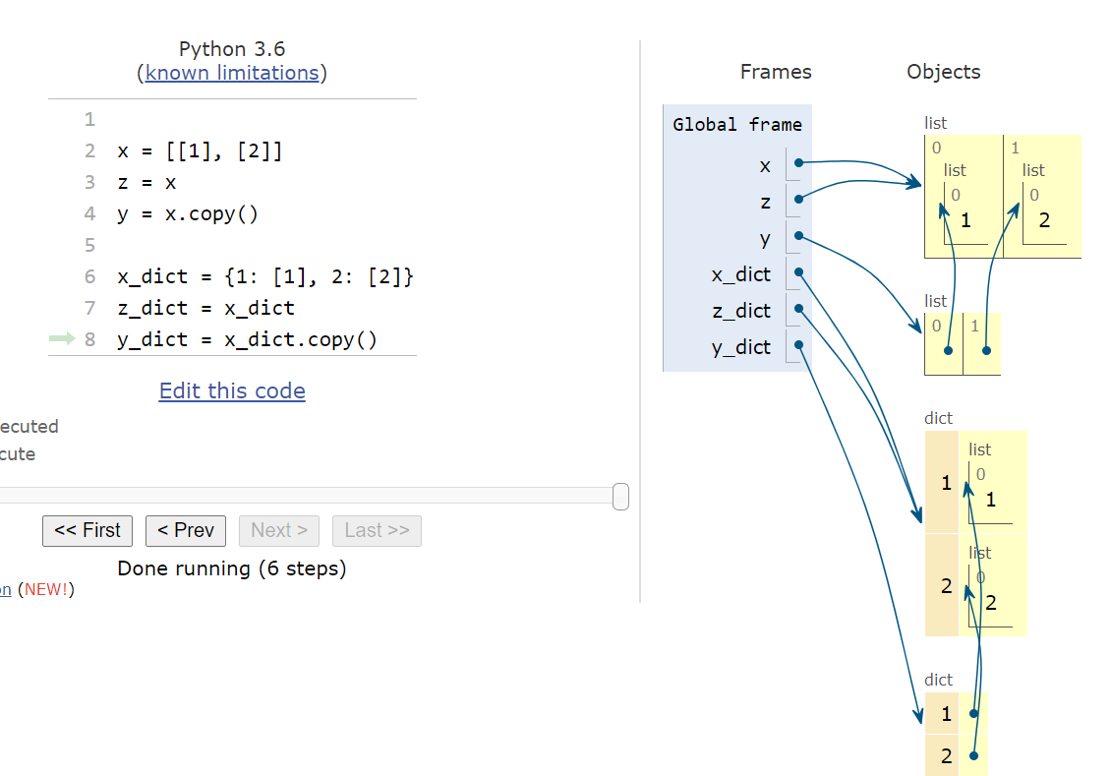

STAY HEALTHY AND WELL!!!!